Send Message to Customer

CRC Card: MessageController
Class | Responsibilities | Collaborators
MessageController | • Accept send message request  • Validate message content  • Delegate message creation and persistence | Customer, Message, MessageDAO

CRC Card: Message
Class | Responsibilities | Collaborators
Message | • Store message content  • Timestamp the message  • Link message to the corresponding customer | Customer

CRC Card: Customer
Class | Responsibilities | Collaborators
Customer | • Maintain customer profile  • Maintain customer message history | Message

CRC Card: MessageDAO
Class | Responsibilities | Collaborators
MessageDAO | • Save message to the database  • Retrieve message history for a customer

FIRST CUT DCD
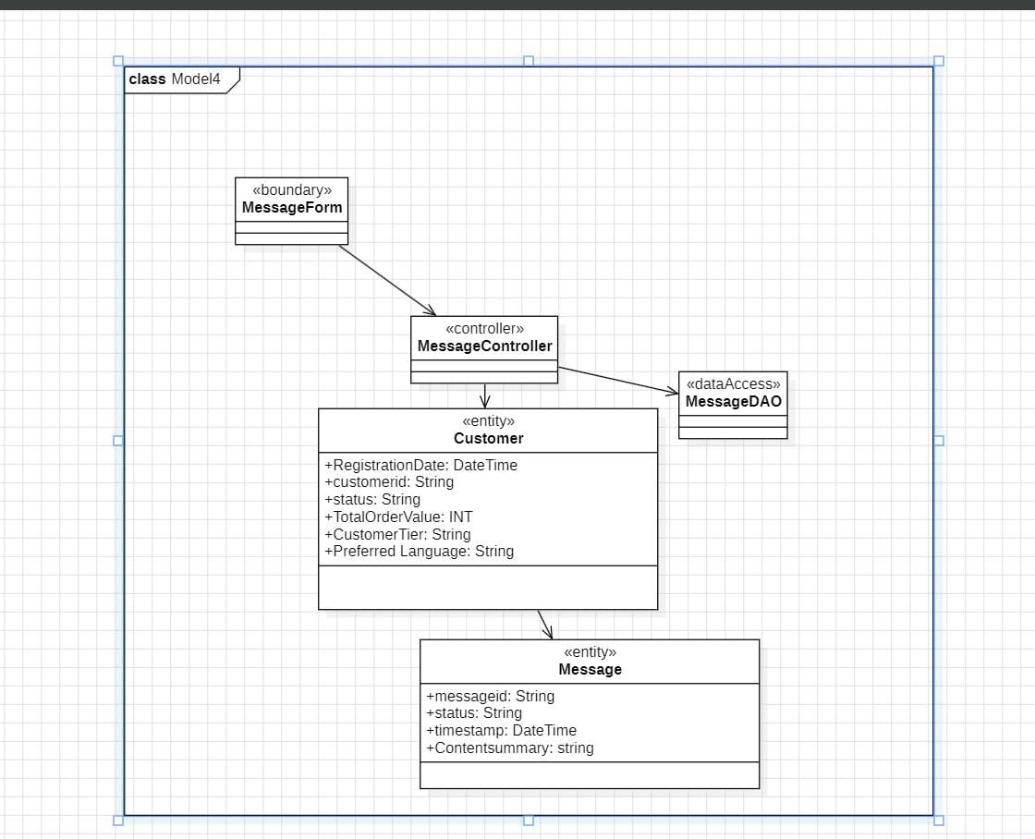
FINAL DCD
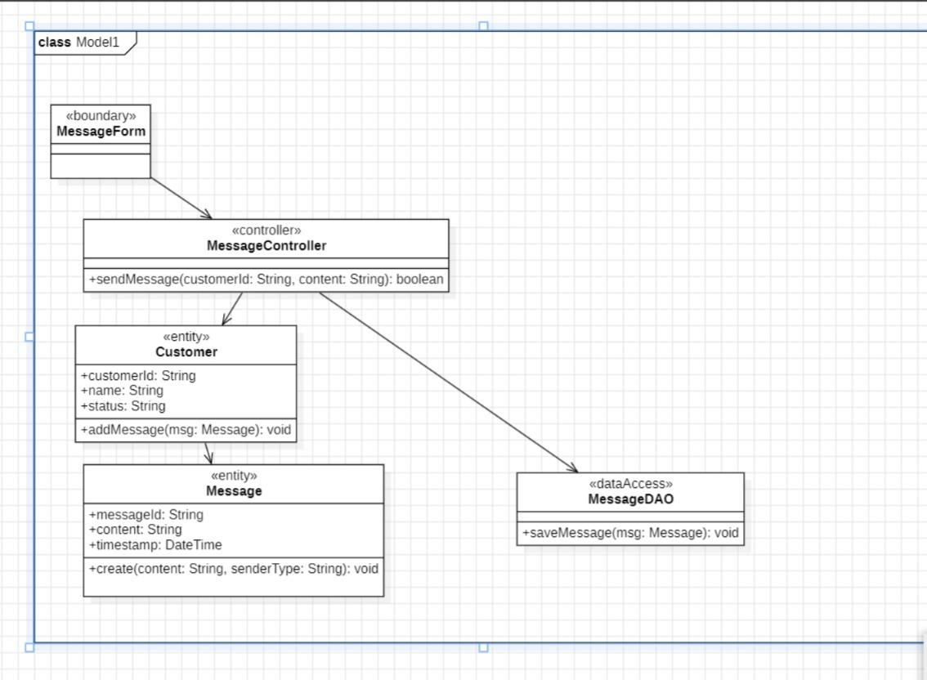

Receive & Route Customer Message
FIRST CUT DCD

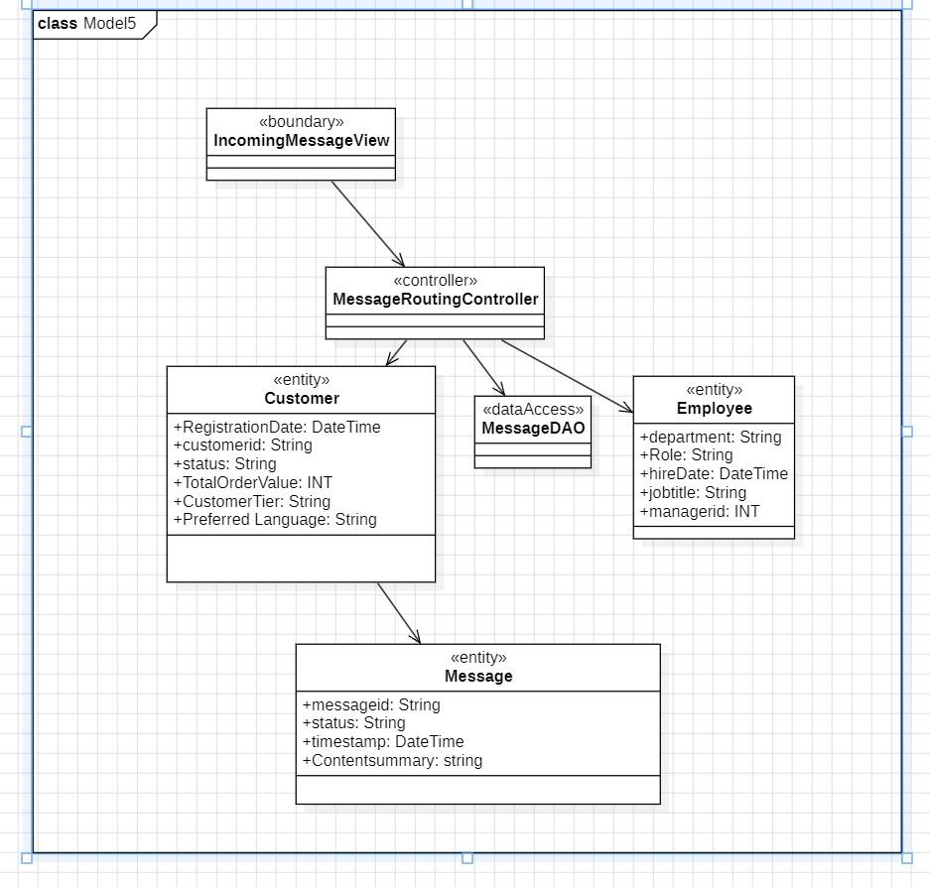

FINAL DCD
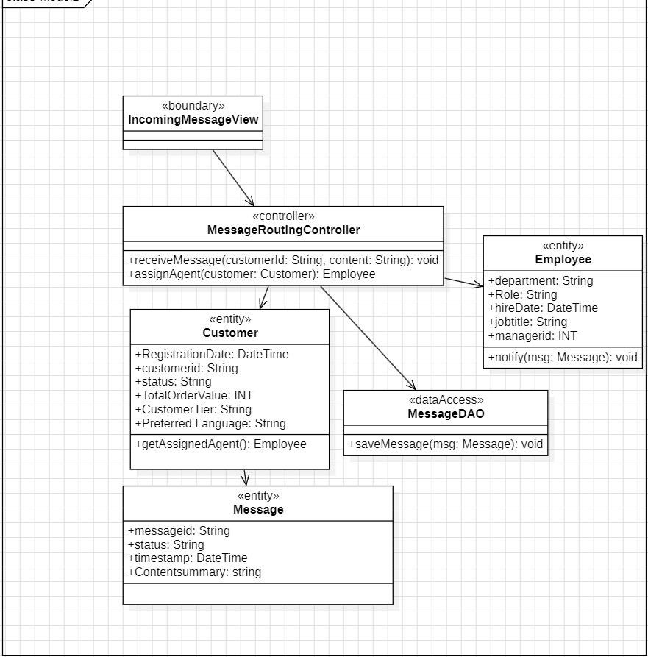

COMMUNICATION DIAGRAM



Generate Active Customer Report
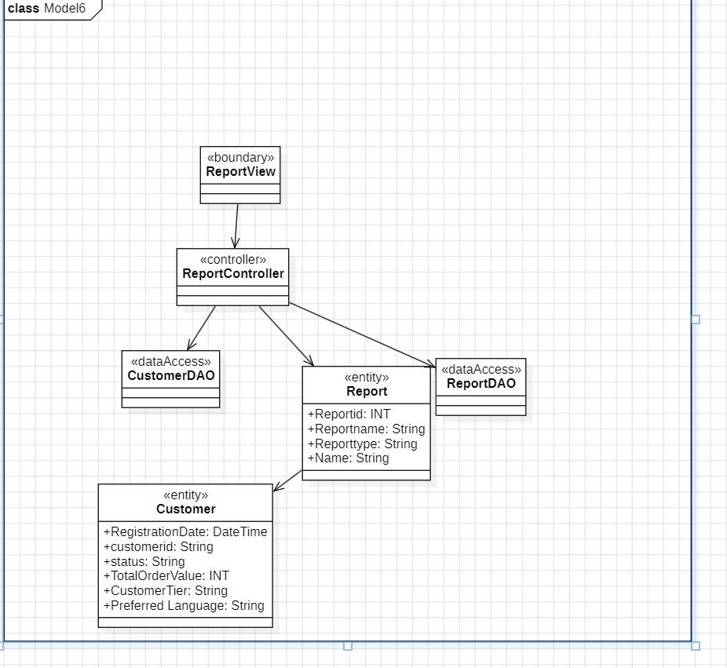
FIRST CUT DCD

FINAL DCD 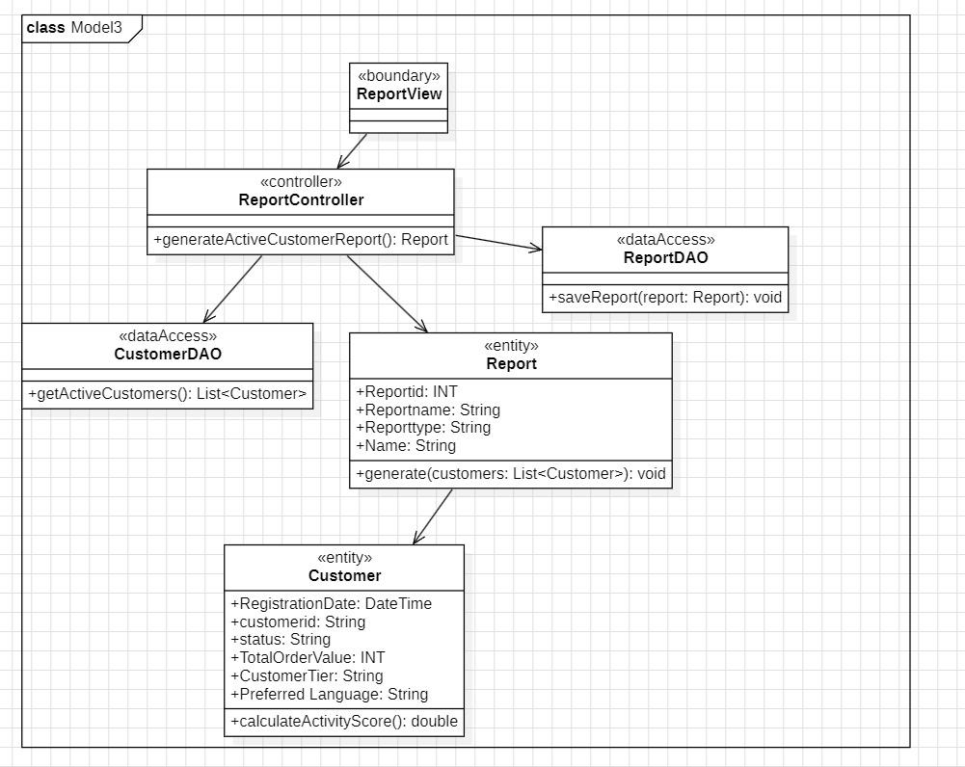

SEQUENCE DIAGRAM 